GREVILLE SMYTH COMMUNITY BOWLS CLUB
Ashton Gate, Bristol, BS3 1RU

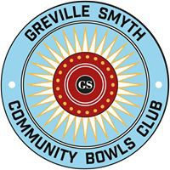

grevillesmythbowls@hotmail.co.uk
gscbc.org.uk

MEMBERSHIP FEE £20 YEAR ENDING OCTOBER 2018

Please print clearly

First Name: ………………………………… Surname: ……………………….……………………..

Post Code: …………..… Contact Phone Number: ………...………………………………

Email: …………………………………………………………………………………………

Age Group  (Please Tick) | 18 to 55 | Over 55

Signed: ................................................................................................ Date……………………….

Volunteering: In which of the following areas would you be willing to help?
Please tick relevant box

Opening up
If so which day/eve:

Functions/Events/Publicity/Fundraising
Maintenance/Cleaning
Coaching
Cash | Cheque | Date Paid |  | BACS |  | Standing Order  Greville Smyth Community Bowls Club Nat West A/c No. 88607356  Sort code 52-10-00  Ref ID

Please be assured we will only use your contact details for the purposes of the club and will not share them with third parties. By signing you agree to your data being stored.

Committee Member Signature: …………………............................... Date: ……………..……...

Fee Paid……………………………… Membership No:….. ……………………………………....

